UNIT – I

1. a) What is an algorithm? Write the various criteria used for judging an algorithm.

- Step by step Procedure to solve a Particular problem is called ALGORITHM
- Algorithm can also be called as Pseudo - Code
- Algorithm can be defined as a well-defined computational procedure that takes single value or a set of values as inputs and produces a single or multiple values as output.
- Thus it is a sequence of steps which transforms an input into an output.
- A single problem may have multiple algorithms. Also, an algorithm is always a language-free computational steps.
- In order to compare algorithms, we must have some criteria to measure the efficiency of our algorithms. Suppose an algorithm has m input data. The time and space used by the algorithm are the two main measures for the efficiency of the algorithm.
- The time is measured by counting the number of key operations— in sorting and searching algorithms,
- The space is measured by counting the maximum of memory
needed by the algorithm.

Characteristics of an Algorithm:

Each and every Algorithm should satisfy the following Criteria:
a. Input
b. Output
c. Finiteness
d. Definiteness
e. Effectiveness

Example: Write an algorithm to find the roots of quadratic equation for all the cases.

Step 1: Input A, B, C
Step 2: Set D = B * B – 4 * A * C
Step 3: If D > 0 then :
(a)Set X1 = (-B + SQRT(D))/ 2 * A
(b)Set X2 = (-B - SQRT(D))/ 2 * A
(c) Print X1, X2
Else if D = 0 then:
(a)Set X = -B / 2 * A
(b)Print X
Else
Print “Roots are imaginary”
End If
Step 4: Exit

1 b) What is a flowchart? Explain the different symbols used in a
FLOWCHART.
1. A flowchart is the pictorial representation of an algorithm.
2. The various steps in an algorithm are drawn in the form of prescribed symbols.
3. The flow of the algorithm is maintained in a flowchart.
4. The various symbols used in a flowchart are as below.

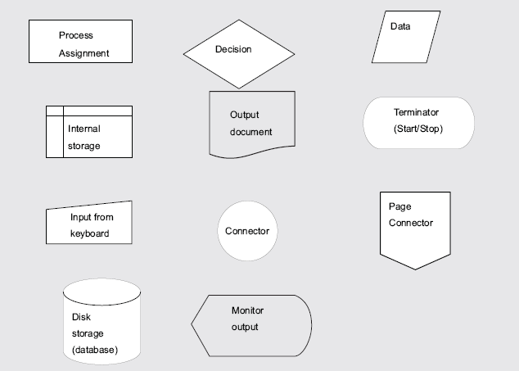

Example:

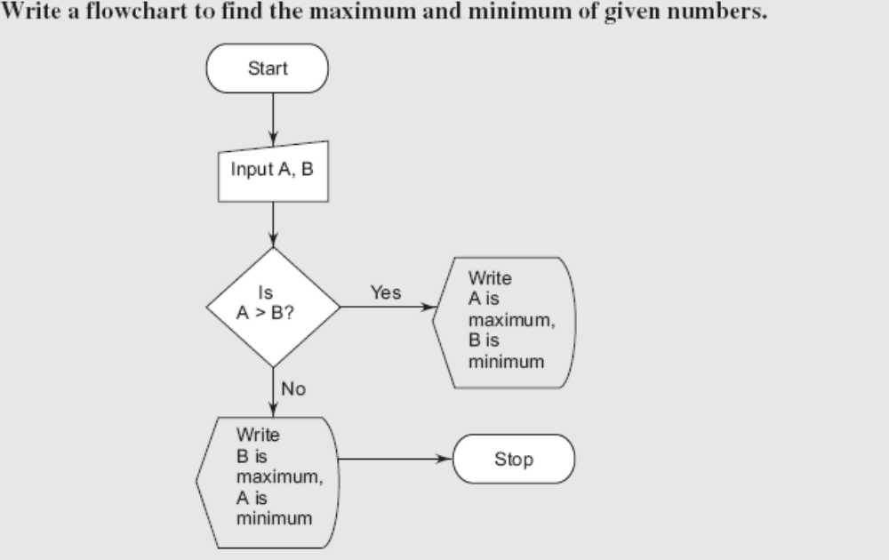

2. a. What is a Variable, How it can be declared, initialized with examples.
b. Write a C program to swap 2 variables using third variable and without using third variable

1. A Variable has a name and type , used to hold some data temporarily.
2. The value of a variable can be altered/ modified later at any time in the program
3. Declaration of a variable:
Syntax: <data type > <variable-name>;
Ex: - int a, b, c;
In the above declaration a,b and c are integer variables which can store some integer data
float c,d,e;
In the above declaration c,d and e are float variables which can store some real data

- Initialization of a variable:
int a,b,c; // a, b, c are declared
a=10;
b=20;
c=30; // a,b,c are initialized with some values , this kind of initialization is called as static initialization .

a,b,c can also be initialized dynamically( at run time)

scanf(“%d%d%d”,&a,&b,&c);

/* program to swap 2 variables using third variable */
#include<stdio.h>
#include<conio.h> // inclusion of header files
void main() // entry point for execution
{
int a,b,temp;

printf(“Enter the values for a and b\n”);
scanf(“%d%d”,&a,&b); // reading a,b values at run time

temp = a;
a = b;
b = temp;

printf(“values of a and b after swapping %d %d\n”,a,b);

getch();
}

/* program to swap 2 variables with out using third variable */
#include<stdio.h>
#include<conio.h> // inclusion of header files
void main() // entry point for execution
{
int a,b;
clrscr();
printf(“Enter the values for a and b\n”);
scanf (“%d %d ”,&a ,&b); // reading a ,b values at run time
a = a+b;
b = a-b;
a = a-b;
printf(“values of a and b after swapping %d %d\n”,a,b);
getch();
}
2 C). i Explain Constants and Different data types.
ii In How many ways constants can be defined

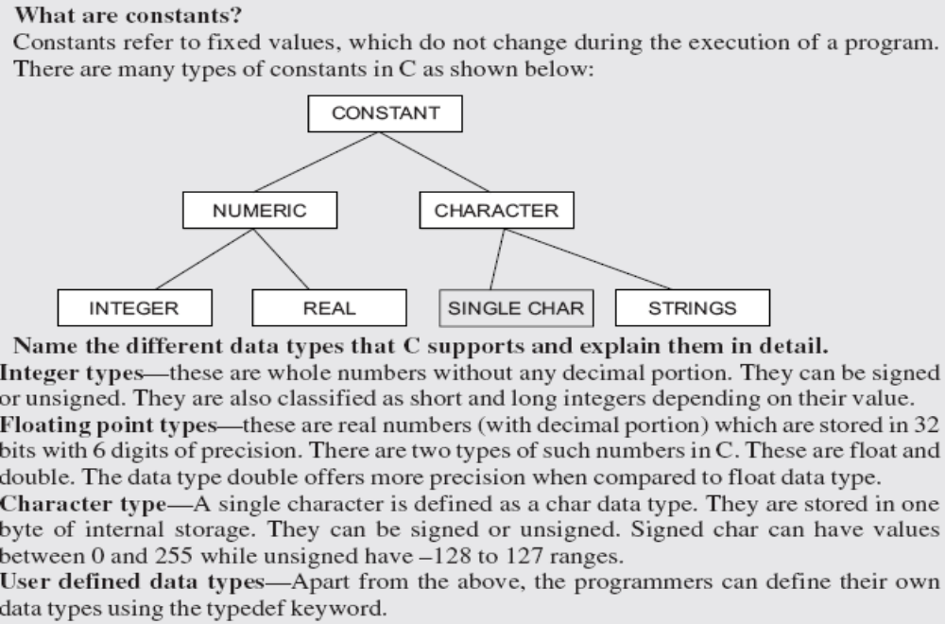

b.
In three ways constants can be defined in a C program
i) using # define
ex:-

#define PI 3.14
#define SIZE 200
#define BANNER “WELCOME”
Whenever we use the above constants the occurrence of each PI will be replaced with its value.

ii) using keyword const
const int size=100;
const float pi=3.1432;
iii) using keyword enum

enum day{mon,tue,wed,thu,fri,sat,sun};
enum Boolean {true,false};

3. Distinguish between the following:
(i) Actual and formal arguments

Actual argument—these are the arguments, which are specified in the function call or calling function
Ex:-
a = gcd (x, y). Here x and y are called the actual arguments

Formal arguments—these are the arguments used in the unction declaration.
Ex :- consider int gcd (int m, int n)
{
// code for finding the gcd for m,n
}
Here m and n are called the formal arguments

(ii) Global and local variables

Global variable—the variables, which are declared outside all the functions (including the main) is, called as global variable. They are available to all the functions.

Ex: -
int a;
float b;
void main()
{
int c;
char d;
}
In the above example a,b are global variables, c,d are local variables.

Local variable—the variables, which are declared within a function, are called local variables. They can be used only within the function in which it is declared.

(iii) Automatic and static variables
Automatic variable—they are created when the function block is entered and removed when the function is terminated. By default, all the variables are automatic variables.
Ex: main()
{
int a;
static int b;
}
In the above example int a can also be considered as auto int a which means all local variables are automatic by default as they are created and deleted automatically.

The variable b is a static variable whose value will be persistent in between the function calls

Static variables—they are variables, which are declared local to a function. However they are available even outside the function in which they are declared.

4. Briefly Explain Control Structures available in C language?

This deals with the various methods that C can control the flow of logic in a program. Control statements can be classified as un-conditional and conditional branch statements and loop or iterative statements. The Branch type includes:

1. Un-conditional:

- goto
- break
- return
- continue

2. Conditional:

- if
- if – else
- Nested if
- switch case statement

3. Loop or iterative:

- for loop
- while loop
- do-while loop

Conditional Statements:

Sometimes we want a program to select an action from two or more alternatives. This requires a deviation from the basic sequential order of statement execution. Such programs must contain two or more statements that might be executed, but have some way to select only one of the listed options each time the program is run. This is known as conditional execution.

if statement:

Statement or set of statements can be conditionally executed using if statement. Here, logical condition is tested which, may either true or false. If the logical test is true (non zero value) the statement that immediately follows if is executed. If the logical condition is false the control transfers to the next executable statement.
The general syntax of simple if statement is:

if (condition)
statement_to_execute_if_condition_is_true;

or

if (condition)
{
statement 1;
statement 2;
_ _ _ _;
}

Flowchart Segment:

Statement 1
if
(Condition)
T
F
if – else statement:

The if statement is used to execute only one action. If there are two statements to be executed alternatively, then if-else statement is used. The if-else statement is a two way branching. The general syntax of simple if - else statement is:

if (condition)
statement_to_execute_if_condition_is_true;
else
statement_to_execute_if_condition_is_false;
Where, statement may be a single statement, a block, or nothing, and the else statement is optional. The conditional statement produces a scalar result, i.e., an integer, character or floating point type.
It is important to remember that an if statement in C can execute only one statement on each branch (T or F). If we desire that multiple statements be executed on a branch, we must block them inside of a { and } pair to make them a single compound statement. Thus, the C code for the flowchart segment above would be:

Flowchart Segment:

Example:
Statement 1
Statement 2

if
(Condition)
T
F

main()
{
int num;
printf(“ Enter a number : “);
scanf(“%d”,&num);
if (num % 2 == 0)
printf(“ Even Number “);
else
printf(“ Odd Number “);
}

Nested if statement:

The ANSI standard specifies that 15 levels of nesting must be supported. In C, an else statement always refers to the nearest if statement in the same block and not already associated with if.

Example:

main()
{
int num;
printf(“ Enter a number : “);
scanf(“%d”,&num);
if( num > 0 )
{
if( num % 2 == 0)
printf(“Even Number“);
else
printf(“Odd Number“);
}
else
{
if( num < 0 )
printf(“Negative Number“);
else
printf(“ Number is Zero“);
}
}

Flowchart Segment:

Statement
Condition 2
Condition 1
T
F
T
F
if-else-if Ladder:

When faced with a situation in which a program must select from many processing alternatives based on the value of a single variable, an analyst must expand his or her use of the basic selection structure beyond the standard two processing branches offered by the if statement to allow for multiple branches. One solution to this is to use an approach called nesting in which one (or both) branch(es) of a selection contain another selection. This approach is applied to each branch of an algorithm until enough additional branches have been created to handle each alternative. The general syntax of a nested if statement is:

if (expression)
statement₁

else if (expression)
statement₂
..
..
else
statement₃

Example:
#include <stdio.h>
void main (void)
{
int N; /* Menu Choice */
printf ("MENU OF TERMS\n\n");
printf ("1. Single\n");
printf ("2. Double\n");
printf ("3. Triple\n");
printf ("4. Quadruple\n\n");
printf ("Enter the numbe (1-4): ");
scanf ("%d", &N);
if (N == 1) printf ("one");
else if (N == 2) printf ("two");
else if (N == 3) printf ("three");
else if (N == 4) printf ("four");
else printf ("ERROR");

}
ERROR
FOUR
THREE
TWO
ONE
N = 1
N = 2
N = 3
N = 4
F
F
F
F
T
T
T
T
The ? : operator (ternary):

The ? (ternary condition) operator is a more efficient form for expressing simple if statements. It has the following form:

expression₁ ? expression₂ : expression₃

It simply states as:

if expression₁ then expression₂ else expression₃

Example:

Assign the maximum of a and b to z:
main()
{
int a,b,z;
printf(“\n Enter a and b “);
scanf(“%d%d”,&a,&b);
z = (a > b) ? a : b;
printf(“Maximum number: %d”, z);
}

which is the same as:

if (a > b)
z = a;
else
z = b;

The switch case statement:

The switch-case statement is used when an expression’s value is to be checked against several values. If a match takes place, the appropriate action is taken. Switch case statement is also known as multi conditional statement . The general form of switch case statement is:
switch (expression)
{
case constant₁:
statement;
break;
case constant₂:
statement;
break;
default:
statement;
break;
}
In this construct, the expression whose value is being compared may be any valid expression, including the value of a variable, an arithmetic expression, a logical comparison rarely, a bit wise expression, or the return value from a function call, but not a floating-point expression. The expression’s value is checked against each of the specified cases and when a match occurs, the statements following that case are executed. When a break statement is encountered, control proceeds to the end of the switch - case statement.
The break statements inside the switch statement are optional. If the break statement is omitted, execution will continue on into the next case statements even though a match has already taken place until either a break or the end of the switch is reached.
The keyword case may only be constants, they cannot be expressions. They may be integers or characters, but not floating point numbers or character string.

Case constants may not be repeated within a switch statement.

The last case is a special keyword default. The default statement is executed if no matches are found. The default is optional and if it is not present, no action takes place if all matches fail.

Three important things to know about switch statement:

- The switch differs from the if in that switch can only test for equality whereas if can evaluate any type of relational or logical expression.

- No two case constants in the same switch can have identical values. But, a switch statement enclosed by an outer switch may have case constants and either same.

- If character constants are used in the switch statement, they are automatically converted to integers.

Flowchart Segment - Case Selection:

In the example below, five possible paths might be followed depending on the value stored in the character storage location X. Each path is selected based on the individual value(s) that might be stored in X.

Example 1:
Statement
Break
Statement

Break

Statement

Break

switch
(expression)
Default
Statement
Next
Statement
Y
Y
Y
N
N
N
N
case 1
match ?
case 2
match ?
case n
match ?

main()
{
char gender;
printf (“Enter Gender code:(M/F)“);
scanf (“%c”, &gender);
switch (gender)
{
case ‘M’ : printf (“ Male“);
break;
case ‘F’ : prrintf (“Female”);
break;
default : printf (“Wrong code“);
}
}

We can also have null statements by just including a “;” or let the switch statement fall through by omitting any statements (see example below).

Example 2:

switch (letter)
{
case `A':
case `E':
case `I' :
case `O':
case `U':
number_of_vowels++;
break;
case ‘ ':
number_of_spaces++;
break;
default:
number_of_constants++;
break;
}

In the above example if the value of letter is `A', `E', `I', `O' or `U' then number_of_vowels is incremented. If the value of letter is ` ' then number_of_spaces is incremented. If none of these is true then the default condition is executed, that is number_of_constants is incremented.

Looping and Iteration:

Looping is a powerful programming technique through which a group of statements is executed repeatedly, until certain specified condition is satisfied. Looping is also called a repetition or iterative control mechanism.

C provides three types of loop control structures. They are:

- for statement
- while statement
- do-while statement

The for statement:

The for loop statement is useful to repeat a statement/s a known number of times.
The general syntax is as follows:

for (initialization; condition; operation)
statement;

The initialization is generally an assignment statement that is used to set the loop control variable.

The condition is an expression(relational/logical/arithmetic/bitwise ….) that determines when the loop exist.

The Operation defines how the loop control variable changes each time the loop is repeated.
We must separate these three major sections by semicolon.

The for loop continues to execute as long as the condition is true. Once the condition becomes false, program execution resumes on the statement following the for. The control flow of the for statement is as follows:

Example 1:

// printing all odd and even numbers between 1 to 5
int x;
main ()
{
for (x=1; x <=5 ; x++)
{
if( x % 2 == 0 )
printf( “ %d is EVEN \n”,x);
else
printf(“ %d is ODD \n”,x);
}
}

Output to the screen:

1 is ODD
2 is EVEN
3 is ODD
4 is EVEN
5 is EVEN

Example 2:

// sum the squares of all the numbers between 1 to 5
main()
{
int x, sum = 0;
for (x = 1; x <= 5; x ++)
{
sum = sum + x * x;
}
printf (“\n Sum of squares of all the numbers between 1 to 5 = %d ”, sum);
}

Output to the screen:

Sum of squares of all the numbers between 1 to 5 = 55

Flowchart Segment - for Statement:

Initialization
Condition
Increment
Statement in
The loop
Next
Statement
The comma ( , ) operator is used to extend the flexibility of the for loop. It allows the general form to be modified as follows:

for (initialization_1, initialization_2; condition; operation_1, operation_2)
statement;

All the following are legal for statements in C. The practical application of such statements is not important here, we are just trying to illustrate peculiar features that may be useful:

1. for (x=0; ((x>3) && (x<9)); x++)
2. for (x=0,y=4; ((x>3) && (y<9)); x++, y+=2)
3. for (x=0, y=4, z=4000; z; z/=10)

The second example shows that multiple expressions can be separated by a , (comma).

Example:

main()
{
int j ;
double degC, degF;
clrscr ();
printf (“\n Table of Celsius and Fahrenheit degrees \n\n”);
printf (“Celsius Degree \t Fahrenheit Degree \n“)
degC = -20.0;
for (j = 1; j <= 6; j++)
{
degC = degC + 20.0;
degF = (degC * 9.0/5.0) + 32.0;
printf (“\n %7.2lf\t\ %7.2lf “, degC, degF);
}
}

Output:

Table of Celsius and Fahrenheit degrees
Celsius Degree | Fahrenheit Degree
0.00  20.00  40.00  60.00  80.00  100.00 | 32.00  68.00  104.00  140.00  176.00  212.00

Nested for loop:

Nested loops consist of one loop placed inside another loop. An example of a nested for loop is:

for (initialization; condition; operation)
{
for (initialization; condition; operation)
{
statement;
}
statement;
}

In this example, the inner loop runs through its full range of iterations for each single iteration of the outer loop.

Example:Program to show table of first four powers of numbers 1 to 9.

#include <stdio.h >

void main()
{
int i, j, k, temp;
printf("I\tI^2\tI^3\tI^4 \n");
printf("--------------------------------\n");
for ( i = 1; i < 10; i ++) /* Outer loop */
{
for (j = 1; j < 5; j ++) /* 1st level of nesting */
{
temp = 1;
for(k = 0; k < j; k ++)
temp = temp * I;
printf ("%d\t", temp);
}
printf ("\n");
}
}

Output to the screen:

I | I ^ 2 | I ^ 3 | I ^ 4
-----------------------------------
1 | 1 | 1 | 1
2 | 4 | 8 | 16
3 | 9 | 27 | 81
4 | 16 | 64 | 256
5 | 25 | 125 | 625
6 | 36 | 216 | 1296
7 | 49 | 343 | 2401
8 | 64 | 512 | 4096
9 | 81 | 729 | 6561

